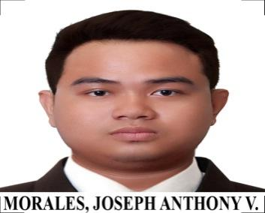
Joseph Anthony V. Morales
518 Bato Street Callejon L Gagalangin Tondo Manila
09202821985- Smart | 09158021495- Globe
Email:josephmo2893@gmail.com
BeHance:https://www.behance.net/josephmo1
Github:github.com/JosephMorales28

Work Experience

August 2017- Digital Tarpaulin Printing
GD Salvador
Juan Luna Street, Tondo Manila

Education

2010-2013- Tertiary
University of the East –Manila
C.M. Recto Avenue
Course: Associate Computer Technology (ACT)

2009-2010- Secondary
University of the East- Manila
C.M. Recto Avenue
4th Year High

2001-2006- Primary
Holy Child Catholic School
Plaza Hernandez Street Tondo Manila
Elementary

Training

2014 & 2017- Basic Computer Literacy, Computer Technician
Honorio M.C. Lopez Technical Institute Inc.
Honorio M.C. Lopez Building, Tayuman Rldg,
Tondo, Manila, 1013 Metro, Manila

2015- Practical Electronics and Consumer Electronics
Meralco Foundation Inc. (MFI)
2240 MFI Building, Taft Avenue, Pasay City

2016- AutoCAD and Revit
Microcadd
Natividad Almeda –Lopez corner A. Villegas and San Marcelino Street, Ermita,
Manila, Manila City.

Skills:

Web Development ( front-end developer)

-HTML5
-CSS3/SCSS
-JavaScript
-PHP&MySQL
-Python
-Vue.Js

Software for Graphic Design

-Adobe Photoshop
-Affinity by Canva

Personal Information:

Gender: Male
Age: 32
Date of Birth: February 28, 1993
Religion: Catholic

Father’s name: Antonio C. Morales Jr.
Occupation: Employee

Mother’s name: Anna Leonicia V. Morales
Occupation: House Wife

I hearby certify that the facts and information contained in this resume are true and correct to the best of my knowledge.

Joseph Anthony V. Morales
Applicant

